**Introduction to Statistical Methods**

**(S2-22_AIMLCZC418) – Assignment 1**

Each question carries 2.5 Marks (2.5 x 4 = 10 Marks)

Duration:

1) Submissions are individual

2) Solve these on paper, scan, and upload

3) Plagiarism results in zero marks

4) Write your name, BITS ID and Section on each page

1. 1. In a school initially there are 100 students with the mean of age 15 and standard deviation 3. Suppose 150 new students are admitted in the school then the mean of the age of 250 students is 15.6 with standard deviation 3.66. Find the mean and the standard deviation of age of newly admitted students.

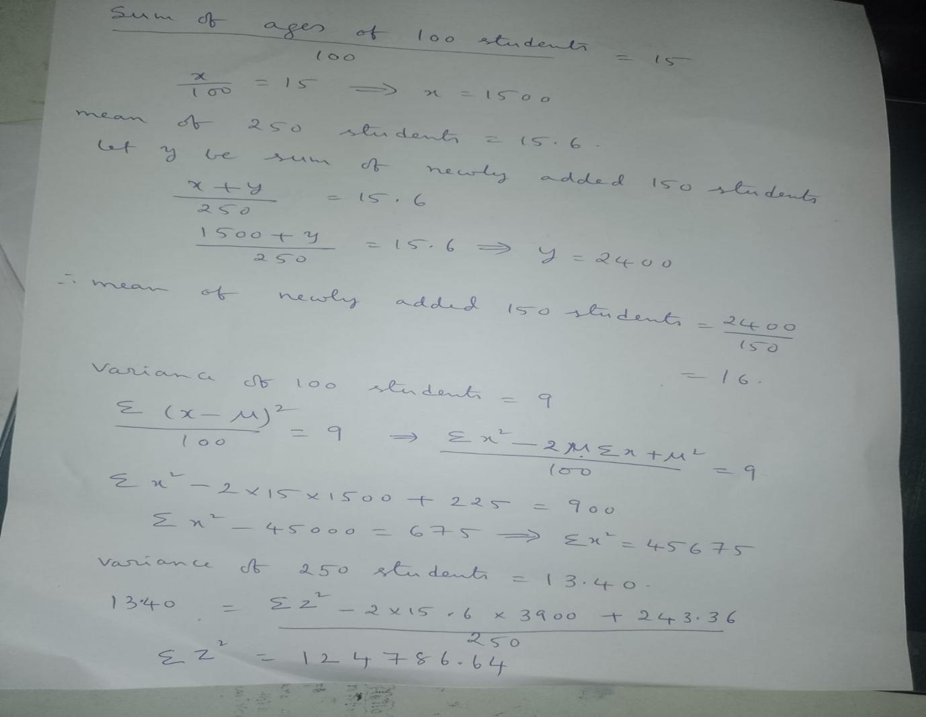

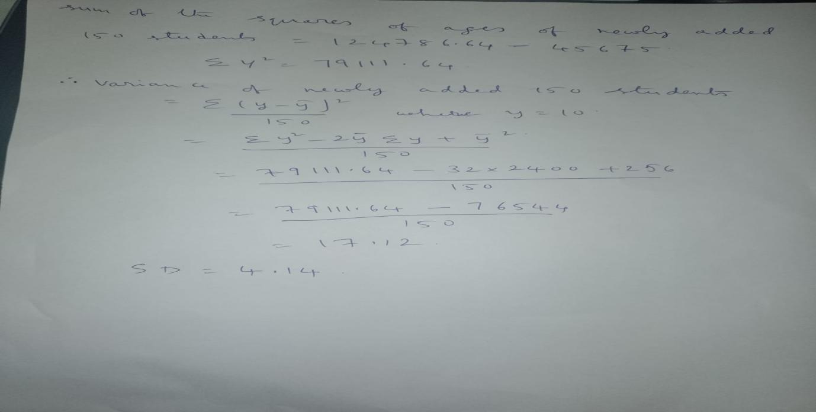

1. Three coins are tossed simultaneously 250 times and the outcomes are recorded as given below.

| **Outcomes** | 3 heads | 2 heads | 1 head | No head | **Total** |
| --- | --- | --- | --- | --- | --- |
| **Frequencies** | 38 | 100 | 64 | 48 | **250** |

If the three coins are again tossed simultaneously at random, find the probability of getting

(i) 1 head

(ii) 2 heads and 1 tail

(iii) All tails

**Solution:**

(i) Total number of trials = 250.

Number of times 1 head appears = 64.

Therefore, the probability of getting

1 head                = Frequency of Favourable Trials/Total Number of Trials

                                 = Number of Times 1 Head Appears/Total Number of Trials

                                                   = 64/250

                                                   = 32/125

(ii) Total number of trials = 250.

Number of times 2 heads and 1 tail appears = 64.

[Since, three coins are tossed. So, when there are 2 heads, there will be 1 tail also].

Therefore, the probability of getting 2 heads and 1 tail

 = Number of Times 2 Heads and 1 Trial appears/Total Number of Trials

 = 100/250

 = 2/5

(iii) Total number of trials = 250.

Number of times all tails appear, that is, no head appears = 48.

Therefore, the probability of getting all tails

= Number of Times No Head Appears/Total Number of Trials

= 48/250

= 24/125

1. A lot contains 32 bulbs out of which 25% are defective. A bulb is drawn at random from the lot. It is found to be non-defective and is not replaced. Now one bulb is drawn at random from the rest. What is the probability that this bulb is not defective?

**Solution:**

No. of defective bulbs = 25% of 32

      = (25/100)x 32

      = 8

So, there are 8 defective bulbs and 24 non-defective bulbs.

After the first draw, the lot has 8 defective bulbs and 23 non-defective bulbs.

So, when the second bulb is drawn, the total number of possible outcomes

= (8+23) = 31

P(Bulb is non-defective) = 23/31 = 0.7419

1. A food production company is polling for new cookies to be launched in the market. The market research team suggests that people of different age groups have different preferences with respect to the product. Suppose the target population is divided into three disjoint age groups A,B and C.

It is observed that 76% of group A favors the product, 47 % of group B favors the product and 54% of group C favors the product. A random sample of 105 people with 35 from group A, 28 from group B and 42 from group C, was chosen and polled. A random vote from the poll suggests that the product is preferred. What is the probability that this vote belongs to a person from group B?

Solution:

